Rising Waters: A Machine Learning Approach to Flood Prediction

Project Description:
Floods are among the most destructive natural disasters, causing major damage to infrastructure, agriculture, and human life. Due to changing climate patterns and unpredictable rainfall, early flood prediction has become essential for disaster management. Traditional forecasting methods are often not sufficient, making machine learning–based systems important for improving prediction accuracy and providing timely warnings.
Flood prediction is challenging because it depends on multiple environmental factors such as rainfall, temperature, humidity, and water levels. Analyzing historical climate data helps identify patterns that indicate flood risk. Early detection allows authorities and communities to take preventive actions and reduce potential losses.
In this project, classification algorithms such as Decision Tree, Random Forest, SVM, XGBoost, and Extra Trees Classifier are trained using environmental features. After performance evaluation, the best-performing model (XGBoost) is selected and integrated into a Flask-based web application, where users can enter environmental details and instantly receive a prediction indicating whether flood risk is High or Low.

Technical Architecture:
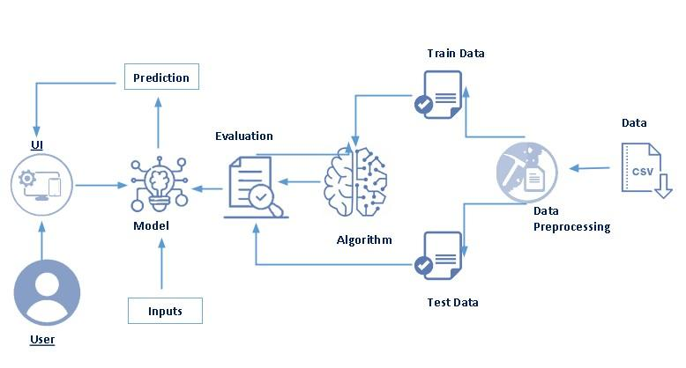

Pre requisites:
To complete this project, you must required following software’s, concepts and packages
- Anaconda navigator and pycharm:
  - Refer the link below to download anaconda navigator
  - Link : https://youtu.be/1ra4zH2G4o0
- Python packages:

  - Open anaconda prompt as administrator
  - Type “pip install numpy” and click enter.
  - Type “pip install pandas” and click enter.
  - Type “pip install scikit-learn” and click enter.
  - Type ”pip install matplotlib” and click enter.
  - Type ”pip install scipy” and click enter.
  - Type ”pip install pickle-mixin” and click enter.
  - Type ”pip install seaborn” and click enter.
  - Type “pip install Flask” and click enter.

Prior Knowledge:
You must have prior knowledge of following topics to complete this project.
- ML Concepts
  - Supervised learning: https://www.javatpoint.com/supervised-machine-learning
  - Unsupervised learning: https://www.javatpoint.com/unsupervised-machine-learning
  - Evaluation metrics: https://www.analyticsvidhya.com/blog/2019/08/11-important-model-evaluation-error-metrics/
  - Metrics: https://youtu.be/aWAnNHXIKww
- Flask Basics : https://www.youtube.com/watch?v=lj4I_CvBnt0

Project Objectives:
By the end of this project you will:
- Know fundamental concepts and techniques used for machine learning.
- Gain a broad understanding about data.
- Have knowledge on pre-processing the data/transformation techniques on outlier and some visualization concepts.

Project Flow:
- User interacts with the UI to enter the input.
- Entered input is analyzed by the model which is integrated.
- Once model analyses the input the prediction is showcased on the UI

To accomplish this, we have to complete all the activities listed below,
- Data collection
  - Collect the dataset or create the dataset
- Visualizing and analyzing data
  - Univariate analysis
  - Bivariate analysis
  - Multivariate analysis
  - Descriptive analysis
- Data pre-processing
  - Checking for null values
  - Handling outlier
  - Handling categorical data
  - Splitting dataset into Dependent And Independent Variables
  - Splitting data into train and test
  - Feature Scaling
- Model building
  - Import the model building libraries
  - Initializing the model
  - Training and testing the model
  - Evaluating performance of model
  - Save the model
- Application Building
  - Create an HTML file
  - Build python code

Project Structure:
Create the Project folder which contains files as shown below
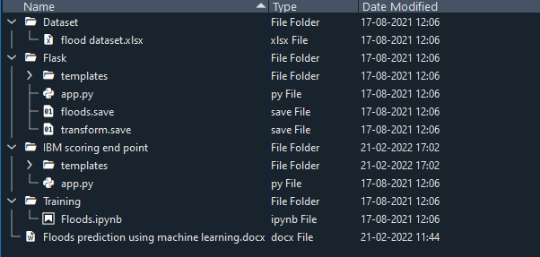
- We are building a flask application which needs HTML pages stored in the templates folder and a python script app.py for scripting.
- floods.pkl is our saved model. Further we will use this model for flask integration.
- Training folder contains model training files and training_ibm folder contains IBM deployment files.

Milestone 1: Data Collection
ML depends heavily on data, It is most crucial aspect that makes algorithm training possible. So this section allows you to download the required dataset.
Activity 1: Download the dataset
There are many popular open sources for collecting the data. Eg: kaggle.com, UCI repository, etc.
In this project we have used Floods_Data.csv data. This data is downloaded from kaggle.com. Please refer to the link given below to download the dataset.
Link: https://www.kaggle.com/datasets/arbethi/rainfall-dataset

Milestone 2: Visualizing and analysing the data
As the dataset is downloaded. Let us read and understand the data properly with the help of some visualization techniques and some analysing techniques.
Note: There is n number of techniques for understanding the data. But here we have used some of it. In an additional way, you can use multiple techniques.
Activity 1: Importing the libraries
Import the necessary libraries as shown in the image. (optional) Here we have used visualization style as fivethirtyeight.
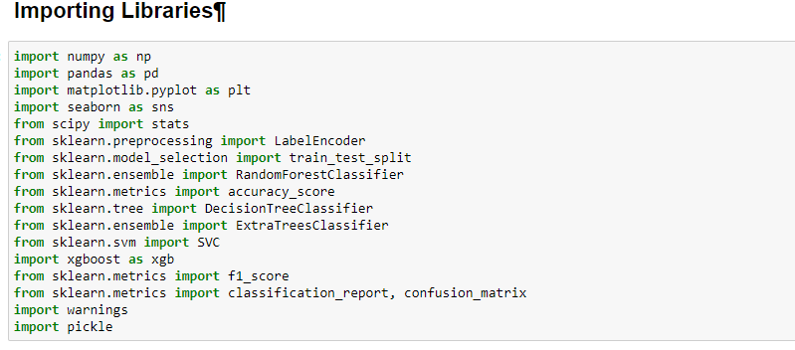
Activity 2: Read the Dataset
Our dataset format might be in .csv, excel files, .txt, .json, etc. We can read the dataset with the help of pandas.
In pandas we have a function called read_csv() to read the dataset. As a parameter we have to give the directory of csv file.
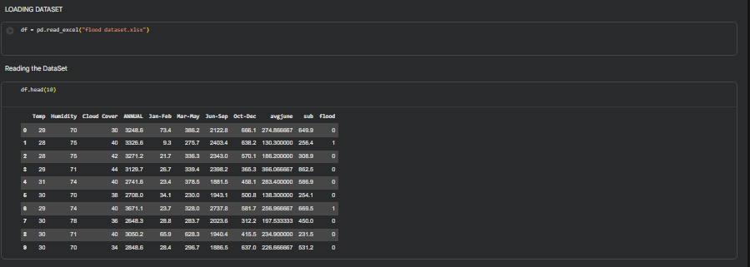
Activity 3: Univariate analysis
In simple words, univariate analysis is understanding the data with single feature. Here we have displayed two different graphs such as distplot and countplot.
- Seaborn package provides a wonderful function distplot. With the help of distplot, we can find the distribution of the feature. To make multiple graphs in a single plot, we use subplot.

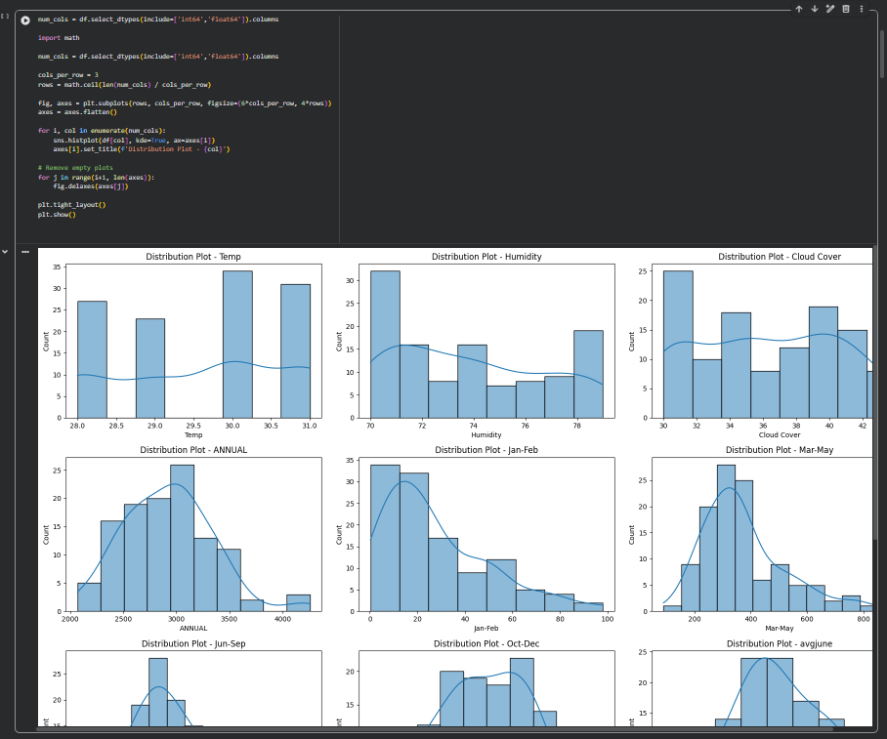

From the above graph, we can infer that the column temp follows some kind of normal distribution, it means the data is normal is almost normal

Box Plots:
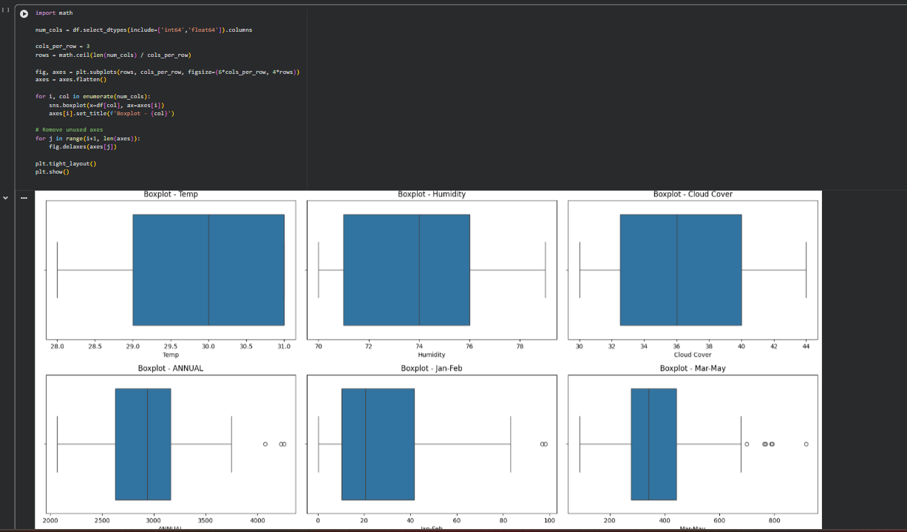

Activity 4: Multivariate analysis
In simple words, multivariate analysis is to find the relation between multiple features.
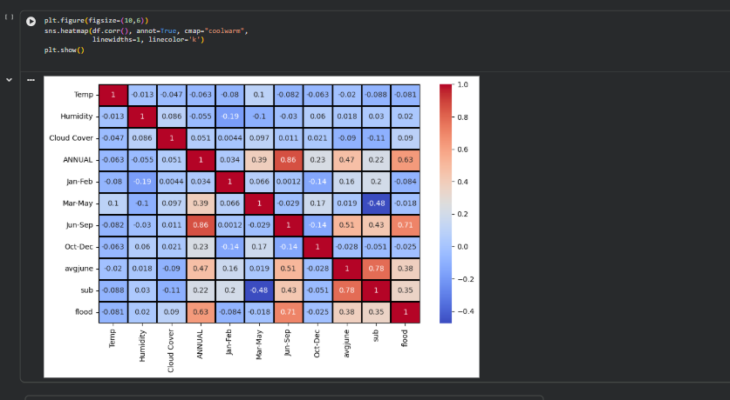
A heat map is a data visualization technique that shows magnitude of a phenomenon as colour in two dimensions. The variation in colour may be by hue or intensity, giving obvious visual cues to the reader about how the phenomenon is clustered or varies over space.
- From the graph, we can identify less correlated values and can drop those variables.

Activity 6: Descriptive analysis
Descriptive analysis is to study the basic features of data with the statistical process. Here pandas has a worthy function called describe. With this describe function we can understand the unique, top and frequent values of categorical features. And we can find mean, std, min, max and percentile values of continuous features.
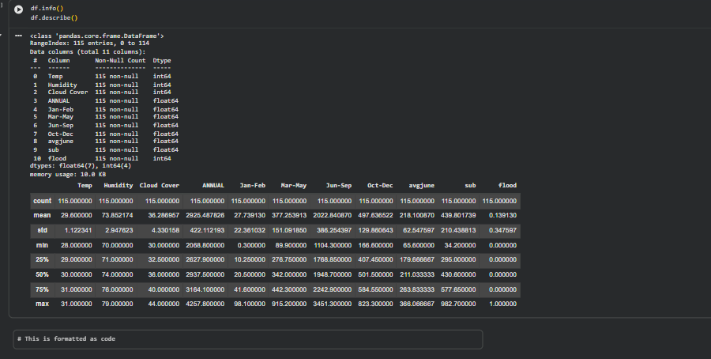

As you can see in our dataset there is no textual data, all the set of data is in float and integer type.

Describe () functions are used to compute values like count, mean, standard deviation give a summary type of data.

Milestone 3: Data Pre-processing
As we have understood how the data is lets pre-process the collected data.
The download data set is not suitable for training the machine learning model as it might have so much of randomness so we need to clean the dataset properly in order to fetch good results. This activity includes the following steps.
- Handling missing values
- Handling categorical data
- Handling outliers
- Splitting dataset into Dependent And Independent Variables
- Splitting data into train and test
- Feature Scaling

Note: These are the general steps of pre-processing the data before using it for machine learning. Depending on the condition of your dataset, you may or may not have to go through all these steps.

Activity 1: Checking for null values

- For checking the null values, df.isnull() function is used. To sum those null values we use .sum() function to it. From the below image we found that there are no null values present in our dataset. So we can skip handling of missing values step.

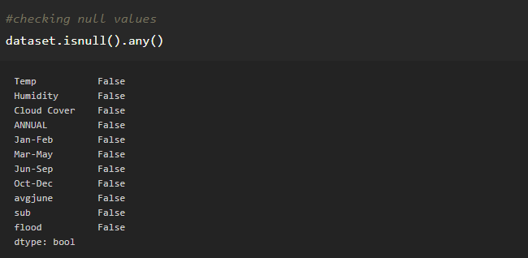

From the above code of analysis, we can infer that columns such as newbalanceOrg, oldbalnceOrig,isFraud are having the missing values, we need to treat them in a required way.

Activity 2: Handling Outliers
With the help of boxplot, outliers are visualized (refer activity 3 univariate analysis). And here we are going to find upper bound and lower bound of Na_to_K feature with some mathematical formula.
- To find the upper bound we have to multiply IQR (Interquartile range) with 1.5 and add it with 3rd quantile. To find lower bound instead of adding, subtract it with 1st quantile. Take image attached below as your reference.
- If outliers are removed, we lose more data. It will impact model performance.
- Here removing outliers is impossible. So, the capping technique is used on outliers.
- Capping: Replacing the outliers with upper bound values.

Note: In our Dataset all the values are in the same range, so outliers replacing is not necessary.

Activity 3: Handeling Categocal Values
As we can see our dataset has categorical data we must convert the categorical data to integer encoding or binary encoding.
To convert the categorical features into numerical features we use encoding techniques. There are several techniques but in our project, we are using feature mapping and label encoding.
Note: In our dataset, there is no categorical data type, so we can skip this step.

Activity 4: Splitting Dataset Into Dependent And Independent Variables
In machine learning, the concept of the dependent variable (y) and independent variables(x) is important to understand. Here, the Dependent variable is nothing but output in the dataset and the independent variable is all inputs in the dataset. We can denote with any symbol (alphabets). In our dataset, we can say that class is the dependent variable and all other columns are independent. But in order to select the independent columns, we will be selecting only those columns which are highly correlated and some value to our dependent column.
· With this in mind, we need to split our dataset into the matrix of independent variables and the vector or dependent variable. Mathematically, Vector is defined as a matrix that has just one column.
· Let’s create out independent and dependent variables:
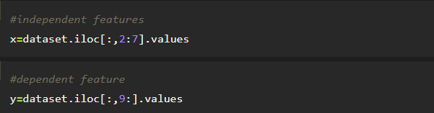

Activity 5: Splitting data into train and test
Now let’s split the Dataset into train and test sets
Changes: first split the dataset into x and y and then split the data set
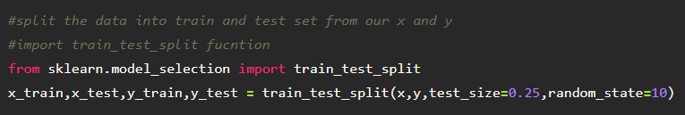
Here x and y variables are created. On x variable, df is passed with dropping the target variable. And on y target variable is passed. For splitting training and testing data we are using train_test_split() function from sklearn. As parameters, we are passing x, y, test_size, random_state.

Activity 6: Feature Scaling
- Standard Scaler: Sklearn its main scaler, the StandardScaler, uses a strict definition of standardization to standardize data. It purely centers the data by using the following formula, where u is the mean and s is the standard deviation.

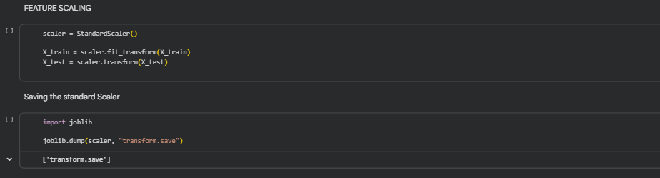

Milestone 4: Model Building
Now our data is cleaned and it’s time to build the model. We can train our data on different algorithms. for this project we are applying four classification algorithms. The best model is saved based on its performance.
Activity 1: Decision tree model
A function named decisionTree is created and train and test data are passed as the parameters. Inside the function, DecisionTreeClassifier algorithm is initialized and training data is passed to the model with .fit() function. Test data is predicted with .predict() function and saved in new variable. For evaluating the model, confusion matrix and classification report is done.
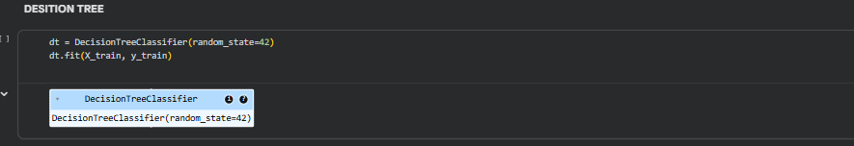
Activity 2: Random forest model
A function named randomForest is created and train and test data are passed as the parameters. Inside the function, RandomForestClassifier algorithm is initialized and training data is passed to the model with .fit() function. Test data is predicted with .predict() function and saved in new variable. For evaluating the model, confusion matrix and classification report is done.
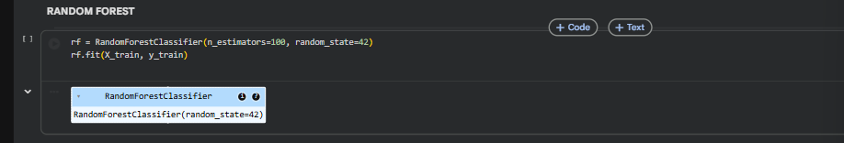
Activity 3: KNN
A function named ExtraTree is created and train and test data are passed as the parameters. Inside the function, ExtraTreeClassifier algorithm is initialised and training data is passed to the model with the .fit() function. Test data is predicted with .predict() function and saved in a new variable. For evaluating the model, a confusion matrix and classification report is done.
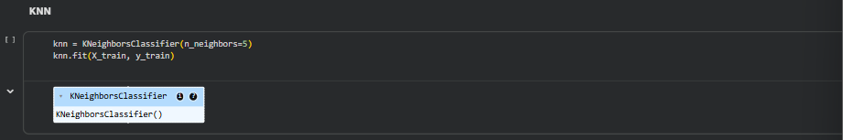

Activity 5: Xgboost model
A function named xgboost is created and train and test data are passed as the parameters. Inside the function, GradientBoostingClassifier algorithm is initialized and training data is passed to the model with .fit() function. Test data is predicted with .predict() function and saved in new variable. For evaluating the model, confusion matrix and classification report is done.
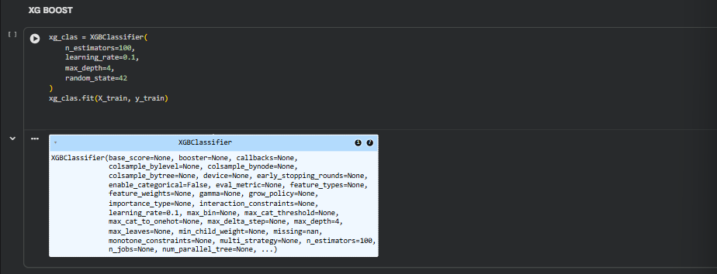
Now let’s see the performance of all the models and save the best model

Activity 5: Compare the model
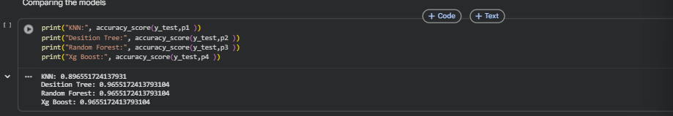
the results of models are displayed as output. From the four model Xgboost is performing well. From the below image, We can see the accuracy of the model. Xgboost is giving the accuracy of 96.5%.so we considering xgboost and deploying this model.

Activity 6: Evaluating performance of the model and saving the model
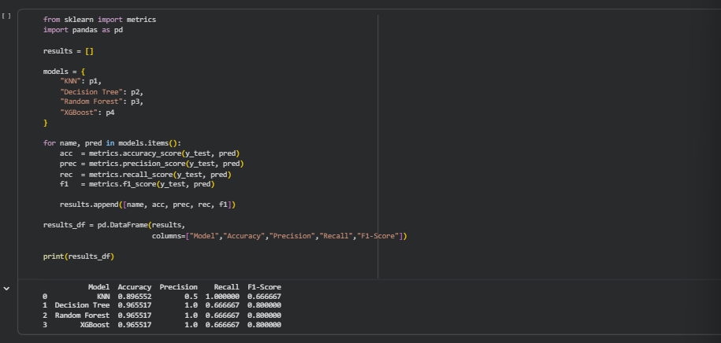

Prefomance evaluation graphs:
Confusion Metrics
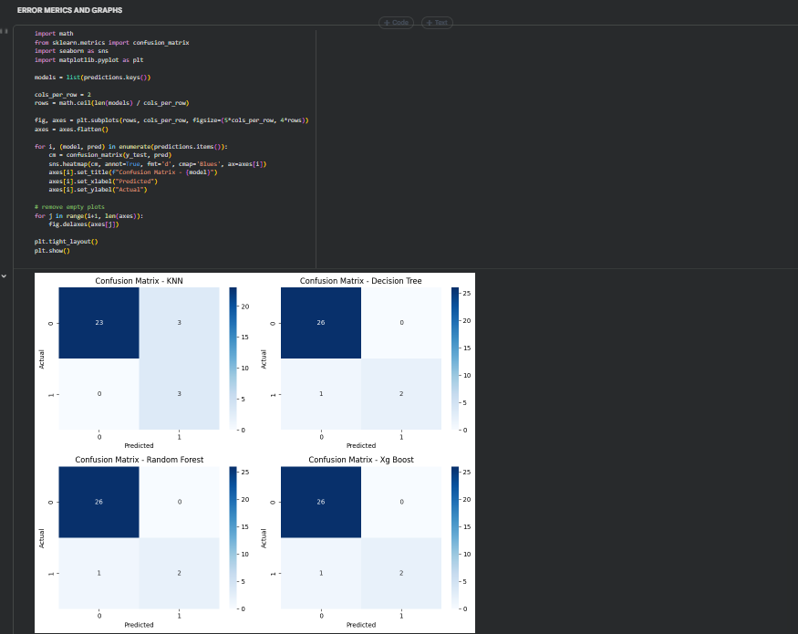
Bar Graphs:
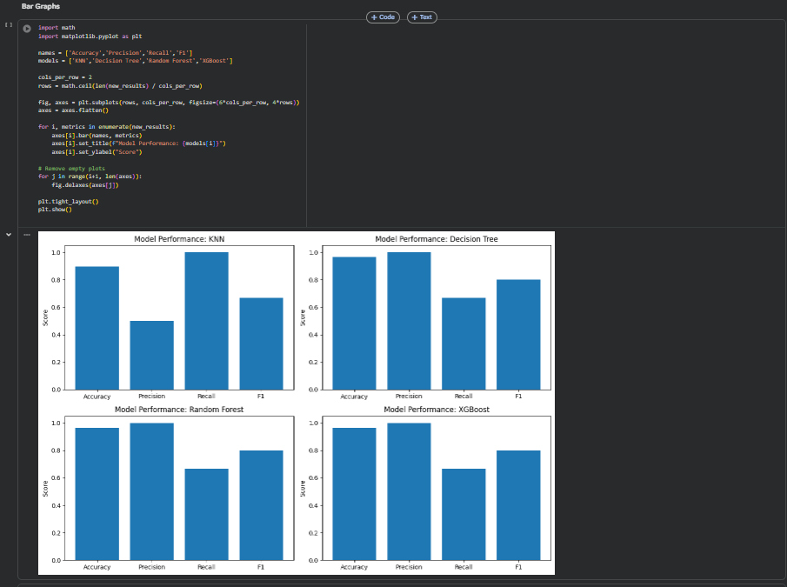
Roc Curves:
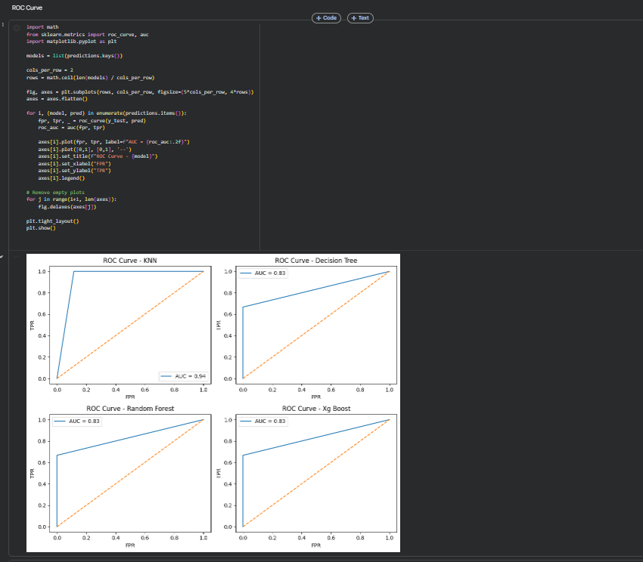
Models Comparison Graph:
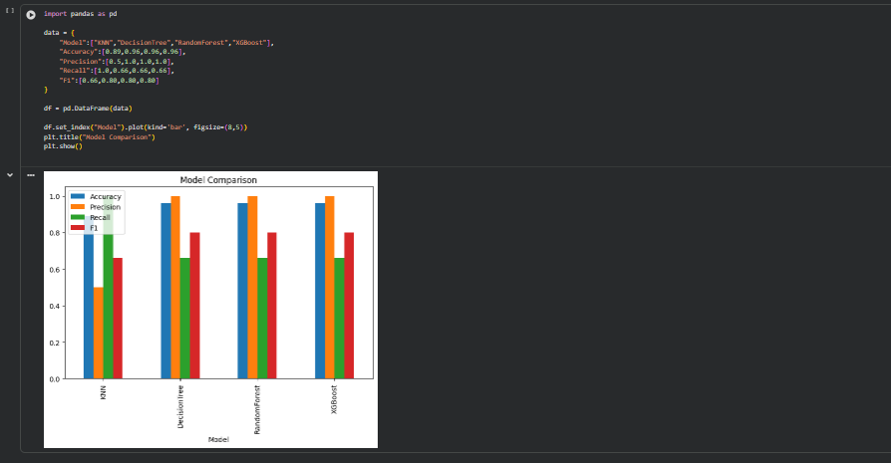
Note: To understand cross validation, refer this link. https://towardsdatascience.com/cross-validation-explained-evaluating-estimator-performance-e51e5430ff85.
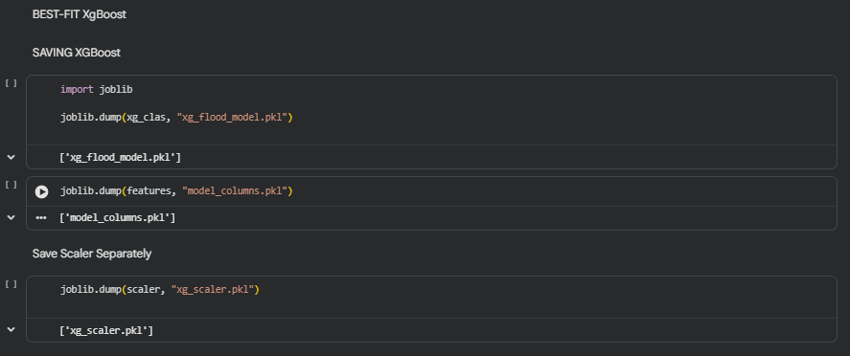

Milestone 5: Application Building
In this section, we will be building a web application that is integrated to the model we built. A UI is provided for the uses where he has to enter the values for predictions. The enter values are given to the saved model and prediction is showcased on the UI.
This section has the following tasks
- Building HTML Pages
- Building serverside script
Activity1: Building Html Pages:
For this project create three HTML files namely
- index.html
- predict.html
- base.html
and save them in templates folder.
Let’s see how our home.html page looks like:
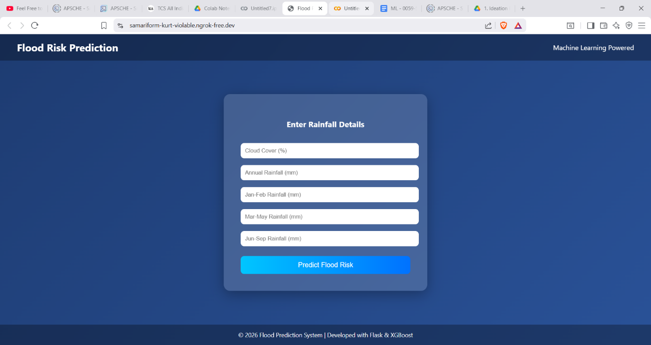
Now when you click on \Predict Flood button from top right corner you will get redirected to predict.html
Lets look how our predict.html file looks like:
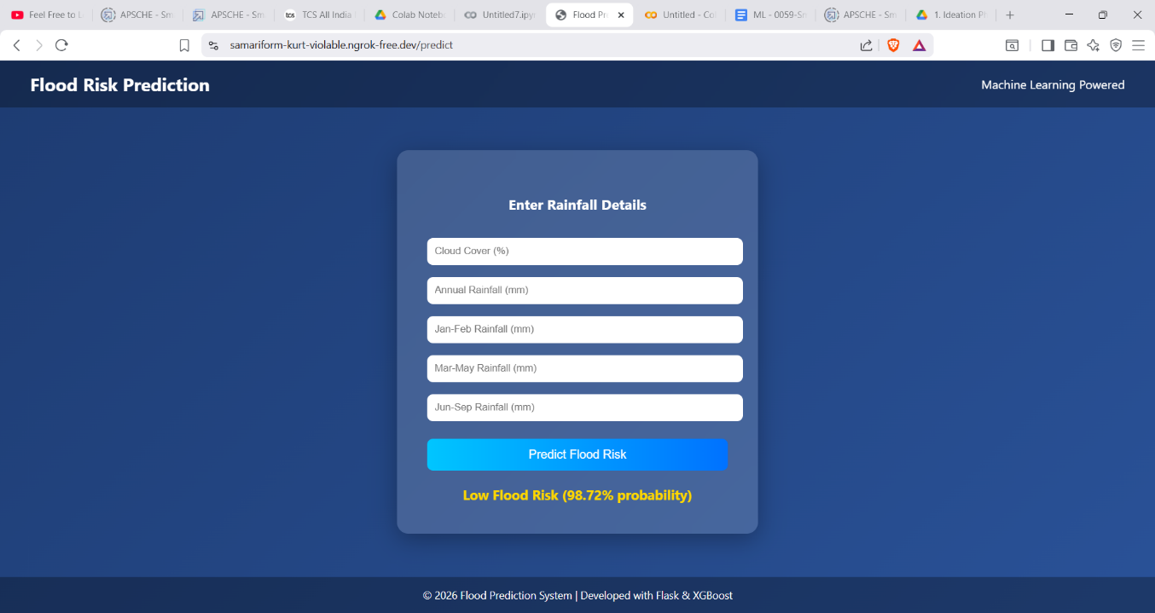
Now when you click on detect button a popup will shown weather the Flood is Expected or Not based on the entered Data.
Lets look how our Pop up looks like:
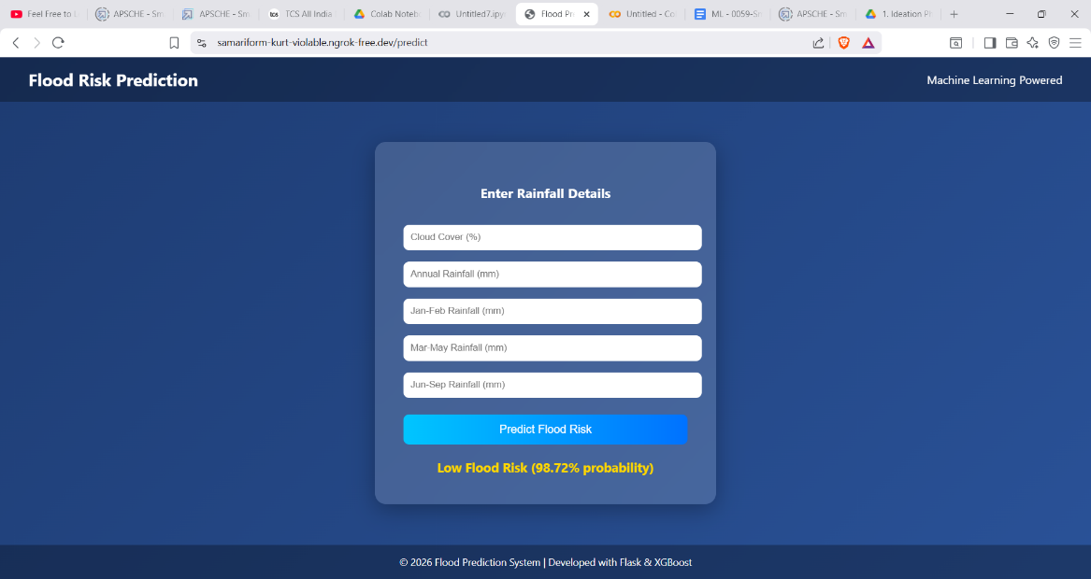
Activity 2: Build Python code:
Import the libraries
Load the saved model. Importing flask module in the project is mandatory. An object of Flask class is our WSGI application. Flask constructor takes the name of the current module (__name__) as argument.
Here we will be using declared constructor to route to the HTML page which we have created earlier.

In the example, ‘/’ URL is bound with index.html function. Hence, when the home page of the web server is opened in browser, the html page will be rendered. Whenever you enter the values from the html page the values can be retrieved using POST Method.
Retrieves the value from UI:
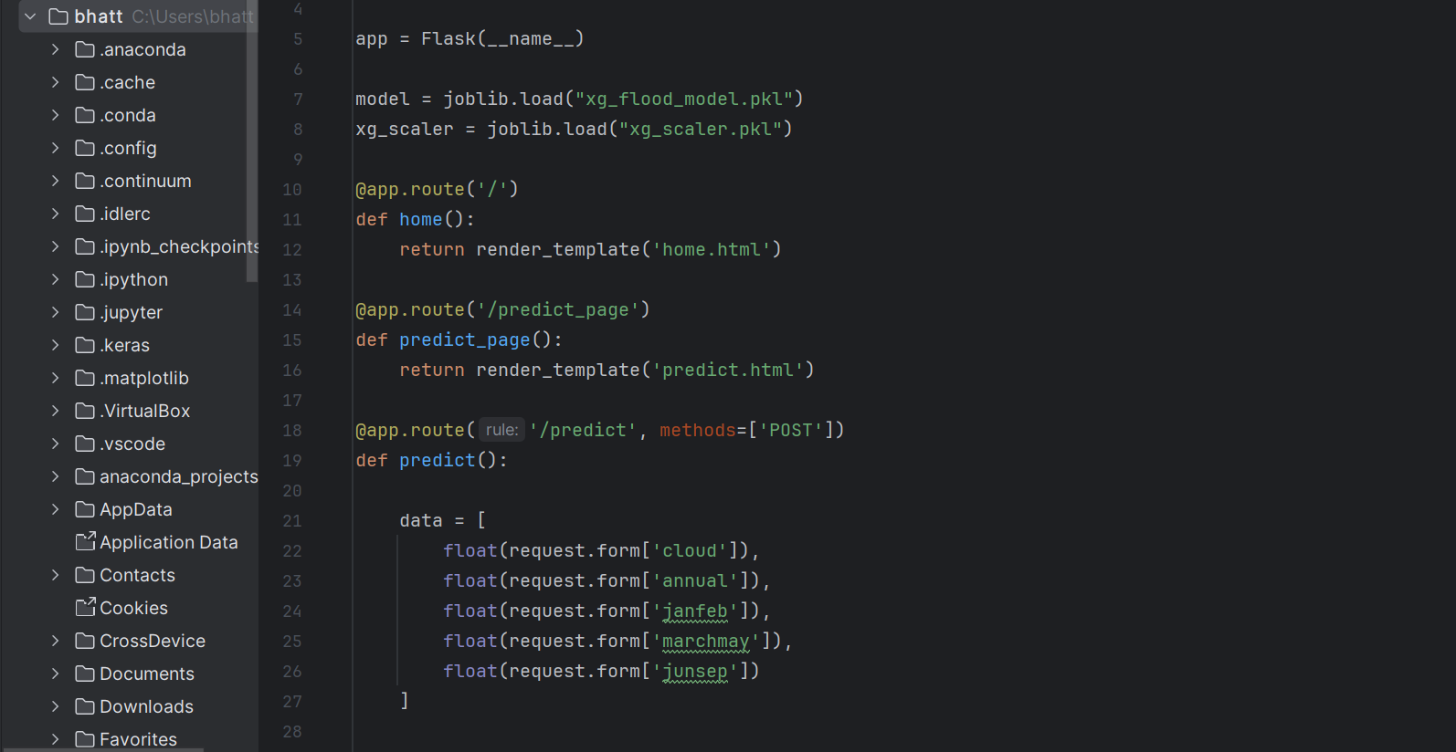

Here we are routing our app to predict() function. This function retrieves all the values from the HTML page using Post request. That is stored in an array. This array is passed to the model.predict() function. This function returns the prediction. And this prediction value will rendered to the text that we have mentioned in the submit.html page earlier.
Main Function:
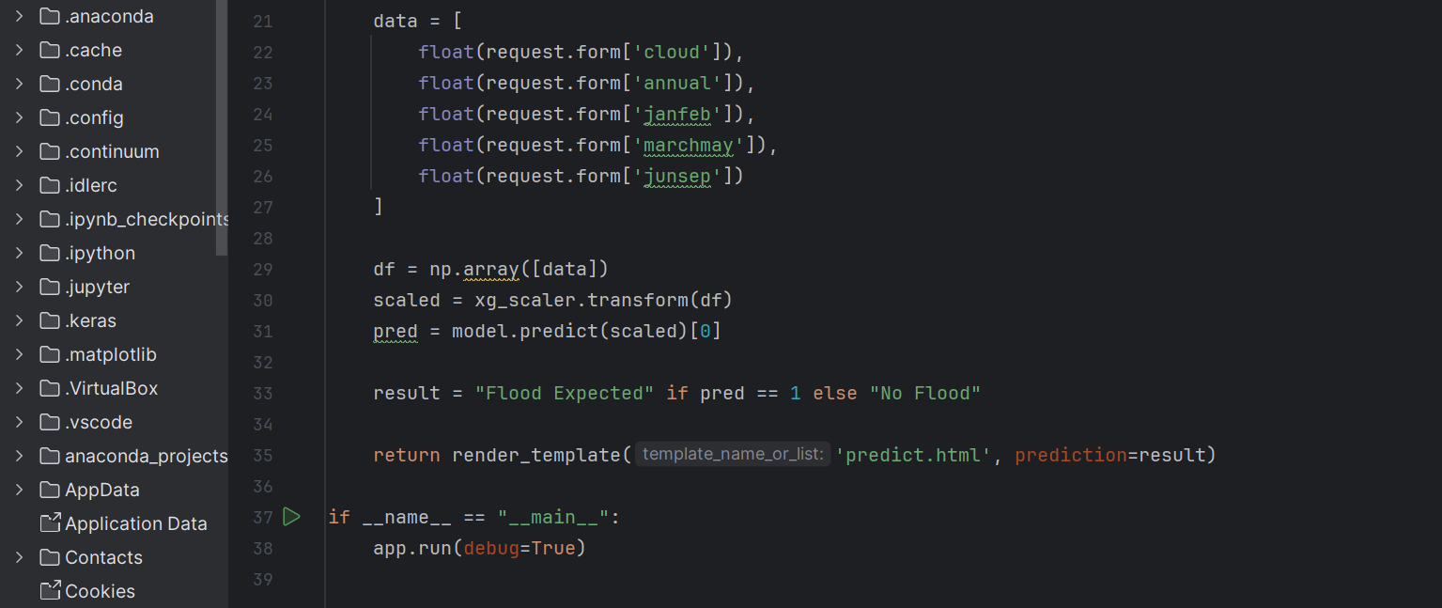
Activity 3: Run the application
- Open anaconda prompt from the start menu
- Navigate to the folder where your python script is.
- Now type “python app.py” command
- Navigate to the localhost where you can view your web page.
- Click on the predict button from top left corner, enter the inputs, click on the submit button, and see the result/prediction on the web.
